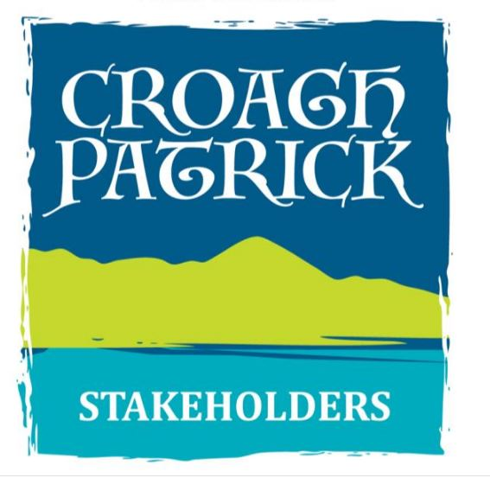

Croagh Patrick Path Manager

- Please refer to the information within the Job Specification for this post regarding eligibility for the post

- The application form, when completed, save as a PDF file, { YOUR NAME_MANAGER }
This should be emailed directly to: croaghpatricksg@gmail.com

- On or before 5 pm, Monday, 31st August 2020

NAME IN FULL
PRESENT ADDRESS
EIRCODE
CONTACT DETAILS  (Notify any change at once) | Home No:  Mobile No:  Email:

EDUCATION: Please outline the highest level of education achieved.

Primary ☐ Group Cert ☐ Inter/Junior Cert ☐ Leaving Cert ☐ Third Level ☐ Trade ☐

School / College Attended

Address

Dates attended

Did you graduate? Yes ☐ No ☐

RESULTS OF LEAVING CERTIFICATE OR EQUIVALENT EXAMINATION

Subject | H - Honours  O - Ordinary | Grade

FURTHER EDUCATION:
Third level academic, professional or technical qualifications (if any)

College | Course Title | Qualification & Grade | Year

TRAINING COURSES:

Course Provider | Course Title | Qualification & Grade | Year

MEMBERSHIP OF PROFESSIONAL INSTITUTIONS

EMPLOYMENT HISTORY

IMPORTANT: Please ensure you list all your career history in the table below, starting with your most recent employment and working backwards until you left full time education. This information is essential to provide us with an overview of your work career to date. If at any stage you were not employed, please describe your situation at the time e.g. Unemployed, Career break, Return to education.

From: | To: | Duration in months:
Employer:
Address:
Nature of Business:
Position Held: |  | Grade (if applicable):
Temporary or Permanent: |  | Part-time or  Fulltime:
Description of main duties and responsibilities

Reason For Leaving:

From: | To: | Duration in months:
Employer:
Address:
Nature of Business:
Position Held: |  | Grade (if applicable):
Temporary or Permanent: |  | Part-time or  Fulltime:
Description of main duties and responsibilities

Reason For Leaving:

From: | To: | Duration in months:
Employer:
Address:
Nature of Business:
Position Held: |  | Grade (if applicable):
Temporary or Permanent: |  | Part-time or  Fulltime:
Description of main duties and responsibilities

Reason For Leaving:

From: | To: | Duration in months:
Employer:
Address:
Nature of Business:
Position Held: |  | Grade (if applicable):
Temporary or Permanent: |  | Part-time or  Fulltime:
Description of main duties and responsibilities

Reason For Leaving:

KEY COMPETENCIES

In the following section of the application form, we are interested in discovering, what are your key strengths and achievements, which make you particularly suitable for the role of

PATH MANAGER
In each of the competency areas below briefly detail 2 examples which you feel best demonstrates your capacity in the competency area described. You may use the same examples across more than one competency area should you so wish. Your examples should show clearly how you have demonstrated the particular competency. You should be mindful that the scale and scope of the examples given demonstrate the competency in question and are appropriate to the position.

- Practical Skills

- A demonstrated commitment to and understanding of the conservation of mountain environments in Ireland.
- Substantial proven practical experience of executing and managing sensitive upland path repair and construction methods to industry standards, as per UPAG Upland Path Standards for Scotland.
- Demonstrated a high skill level in hand-build techniques

Please give examples of where you have demonstrated this.

- Interpersonal & Communication Skills

- Builds and maintains contact with colleagues and other stakeholders to assist in performing the role.
- Acts as an effective link between Trainees and Directors.
- Treats others with diplomacy, tact, courtesy and respect, even in challenging circumstances.
- Presents information clearly, concisely and confidently when speaking and in writing.
- Provides positive support for the consented plan for sustainable access and habitat restoration.
- Demonstrates a capacity to engage positively with the public.

Please give examples of where you have demonstrated this.

- Management & Training

- Experience of Team Work including recruiting and retaining path workers, and of providing effective training and on-site supervision for staff and volunteers
- Builds and maintains contact with colleagues and other stakeholders to assist in performing the role.
- Acts as an effective link between trainees and company directors.
- Encourages open and constructive discussions around work issues.
- Places high importance on staff development, training and maximising skills and capacity of the team.
- Works with the team to facilitate high performance, developing clear and realistic objectives and addressing any performance issues if they arise.

Please give examples of where you have demonstrated this.
- Regulations

- Practical experience in the application of Health and Safety regulations and good safety practice in the mountain setting.

Please give examples of where you have demonstrated this.

RELEVANT PROJECTS:

Please provide relevant project information that provides support of the criteria and competencies that are required for this position as listed in the Job Specification document. Please include the scale, deliverables and budgets involved.

Any additional information you wish to give in support of your application.

Will you be able to attend for interview in Westport, County Mayo, in line with Covid-19 Guidelines?

YES ☐ NO ☐

Or

Will you require online facilities for an interview?

YES ☐ NO ☐

If successful can you join the team in early October 2020?
YES ☐ NO ☐

Have you any objections to the Interview Panel contacting your present and/or previous employers?
YES ☐ NO ☐

Special Requirements:
Please detail any special needs or requirements you may have, and how these can be facilitated during the recruitment process.

Declaration:

I hereby declare that I have complied with all the requirements on the attached checklist and all the particulars furnished in connection with this application are true, and that I am aware of the qualifications and particulars for this position.

I understand that I may be required to submit documentary evidence in support of any particulars given by me on my application form.

I understand that any false or misleading information submitted by me will render me liable to automatic disqualification or render me liable to dismissal if employed.

I hereby authorise The Directors of The Croagh Patrick Stakeholder CLG to seek any additional information they may require in connection with my application for the post.

Signature of applicant: _____________________________ Date: __________________

